**ISCSI mapping on linux client with TrueNas**

yum install iscsi-initiator-utils

cd /etc/iscsi/

[root@server iscsi]# ls

initiatorname.iscsi iscsid.conf

[root@server iscsi]# cat initiatorname.iscsi

InitiatorName=iqn.1994-05.com.redhat:a340924abb93

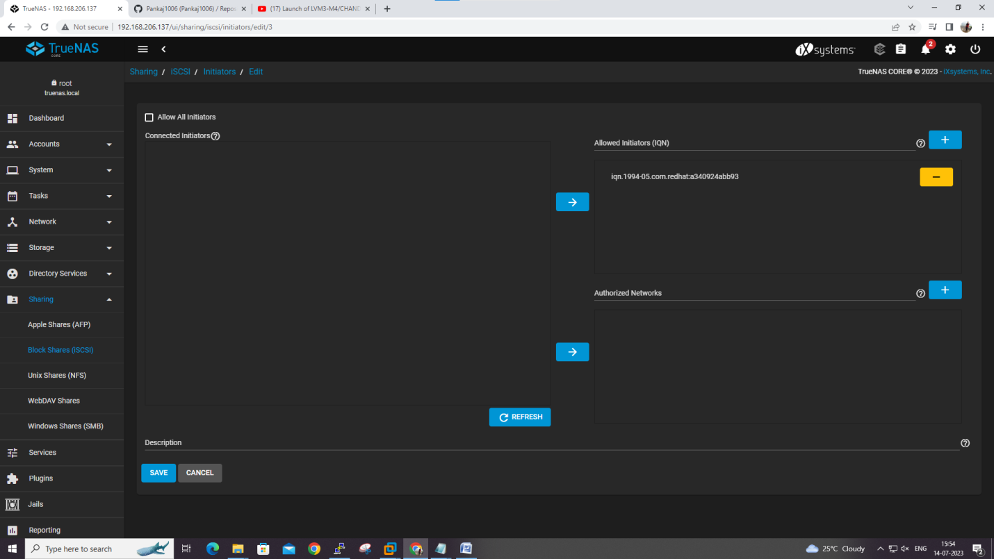

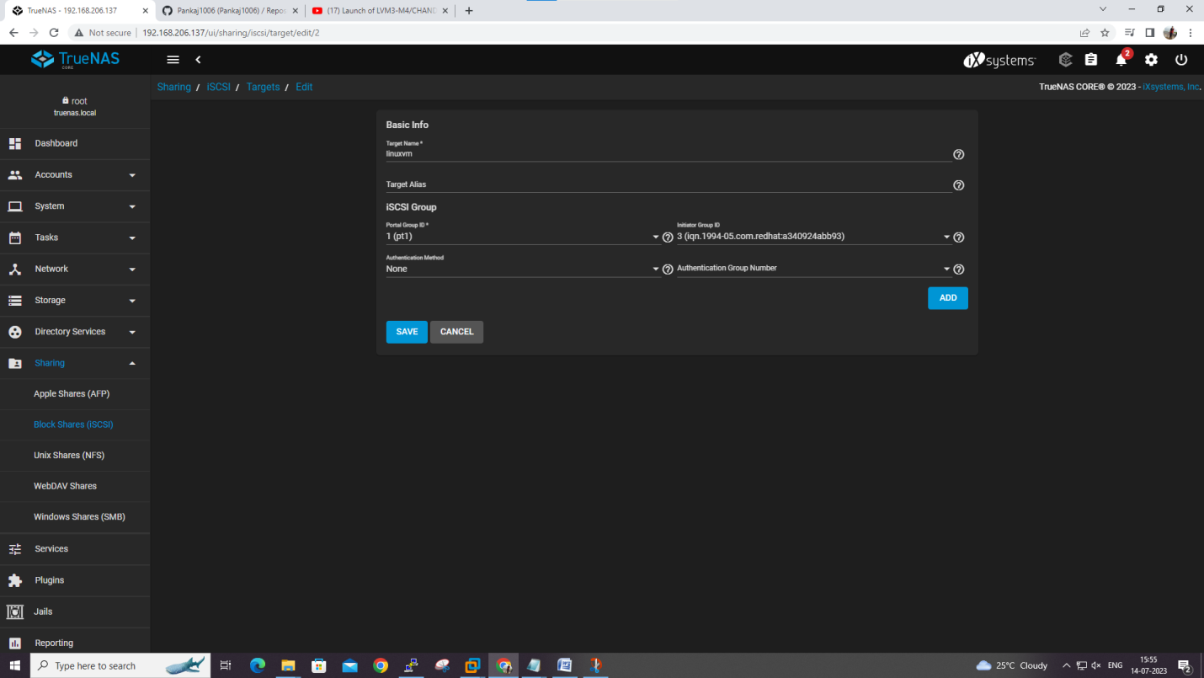

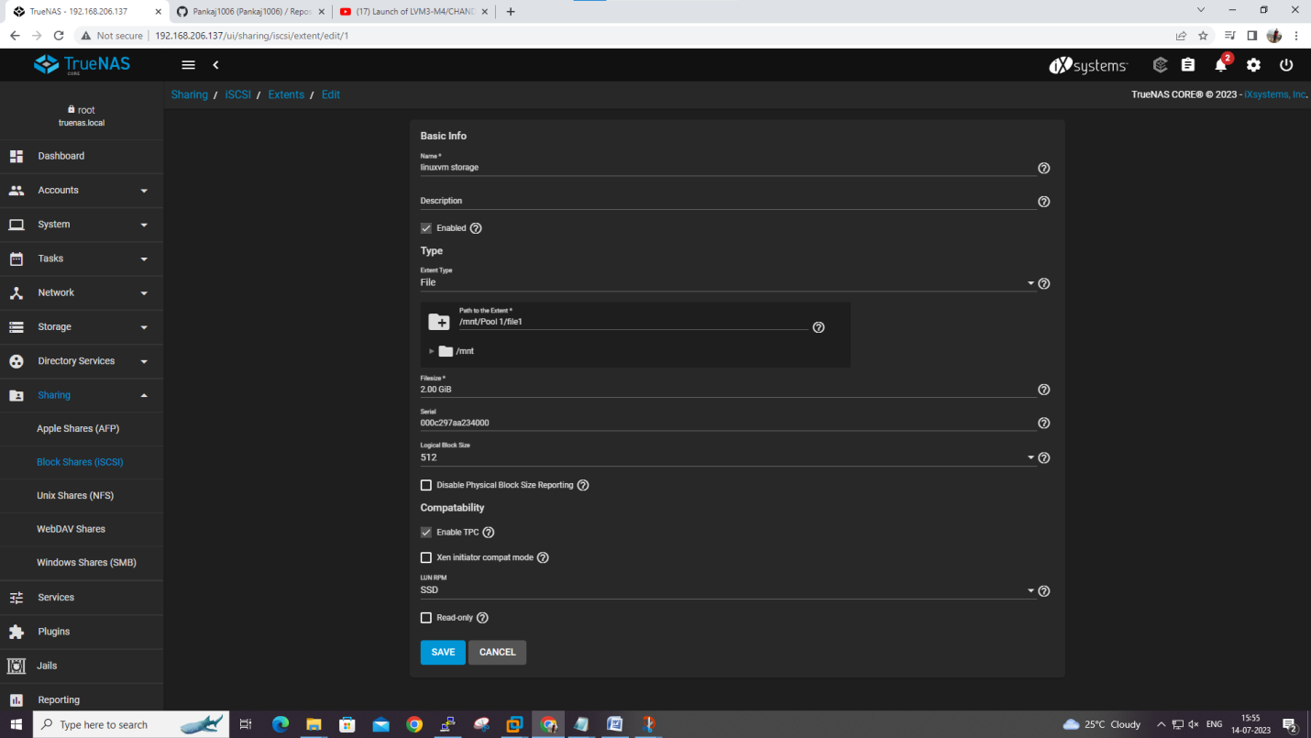

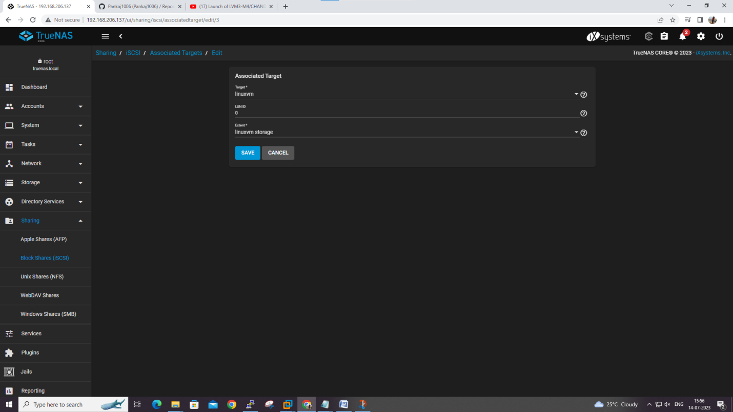

[root@server iscsi]# iscsiadm -m discovery -t st -p 192.168.206.137

192.168.206.137:3260,-1 iqn.2005-10.org.freenas.ctl:windows

192.168.206.137:3260,-1 iqn.2005-10.org.freenas.ctl:linuxvm

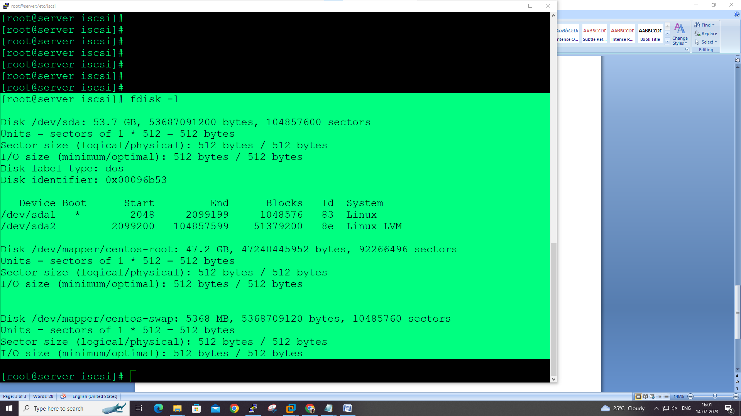

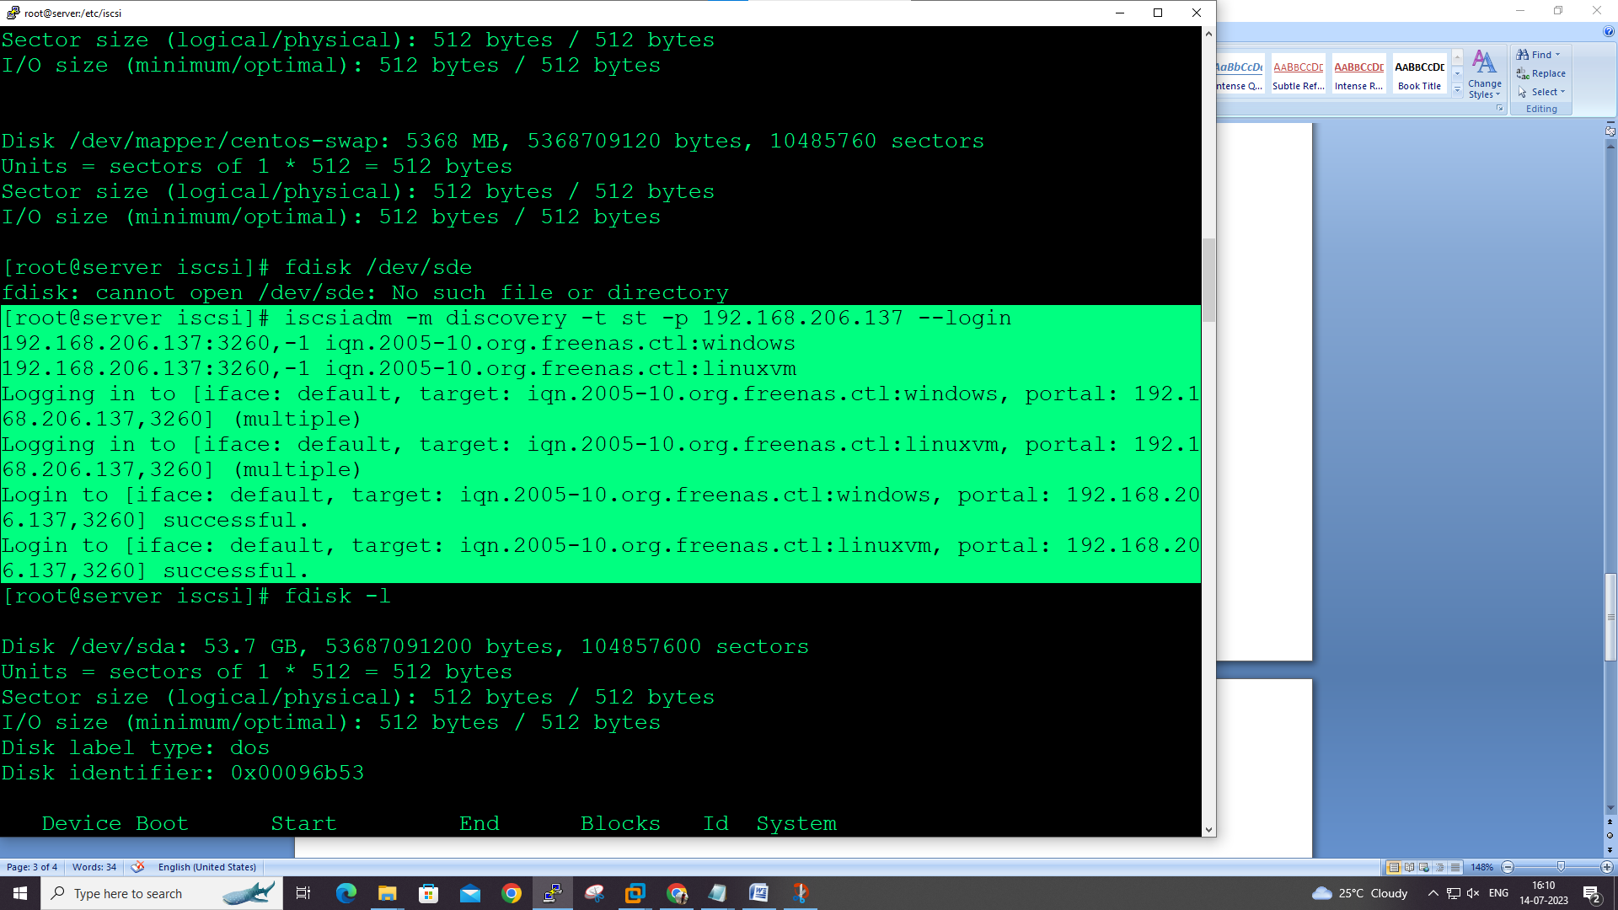

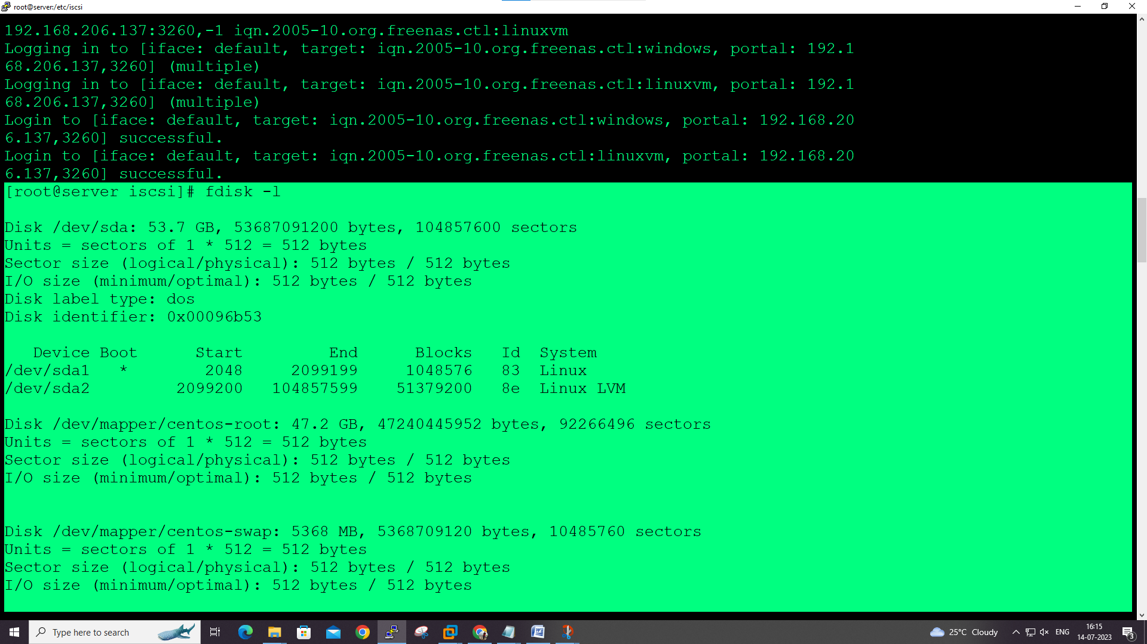

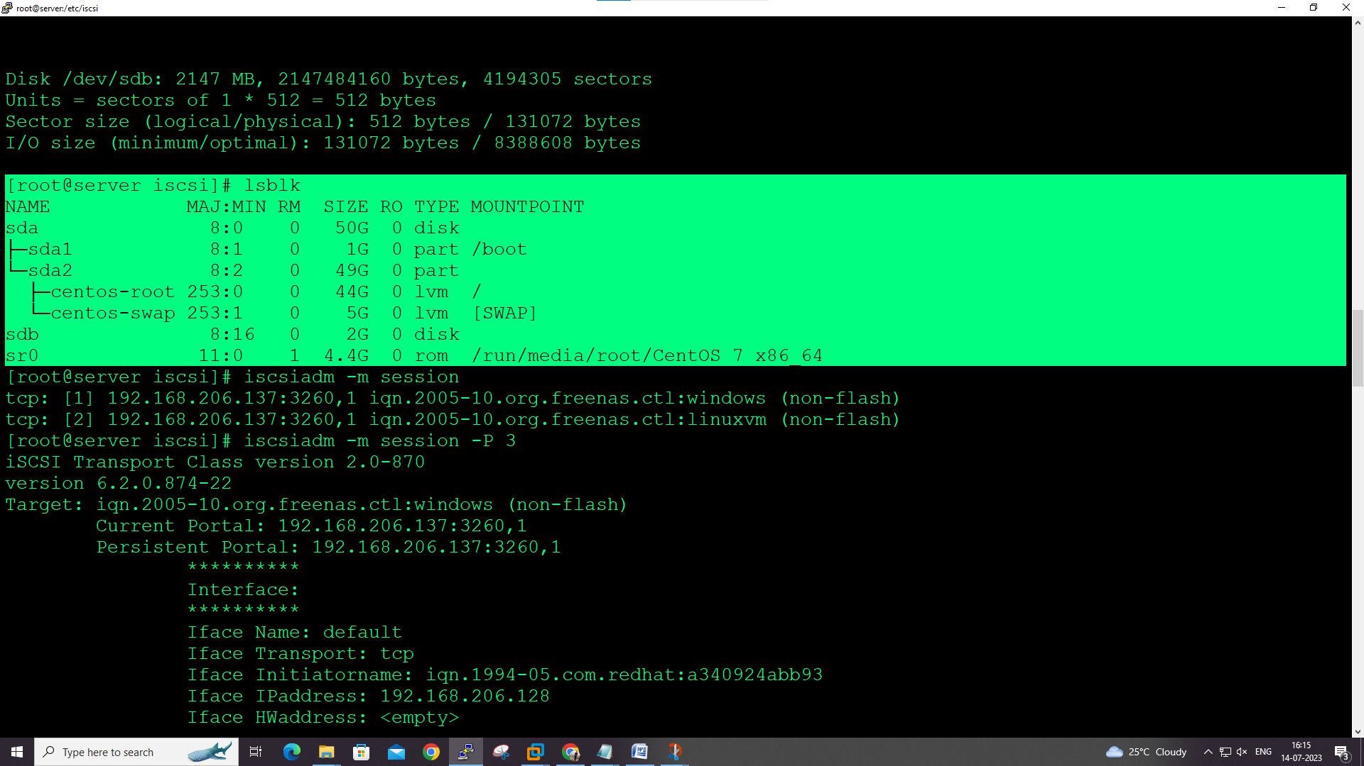

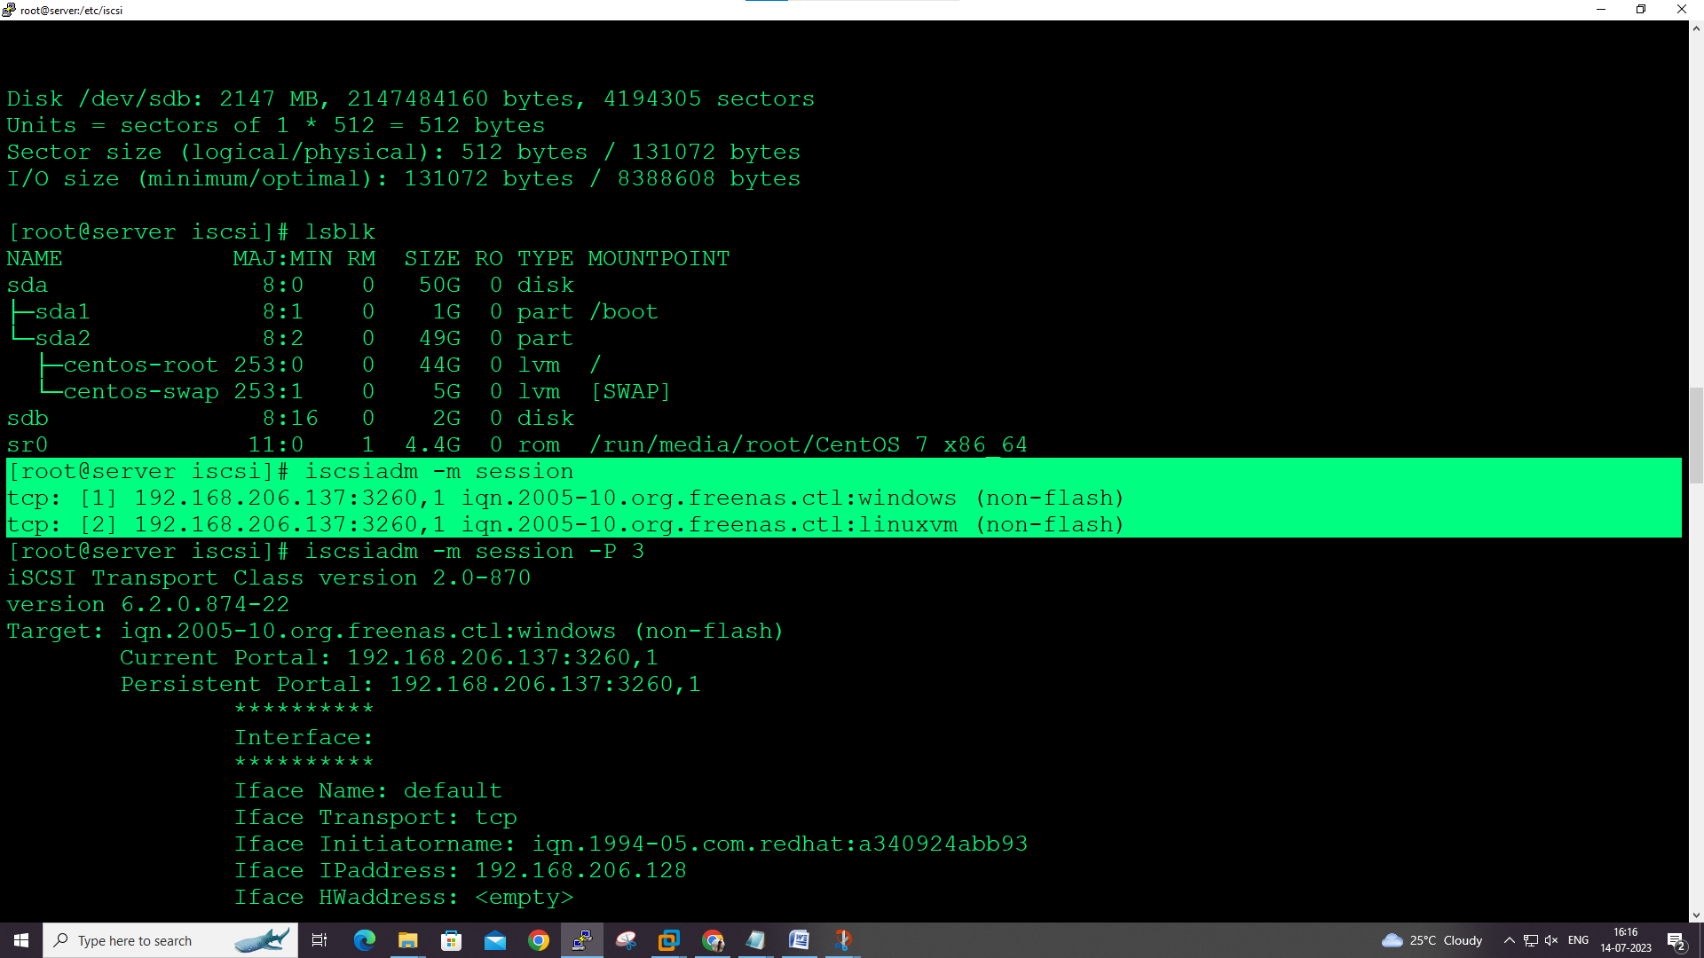

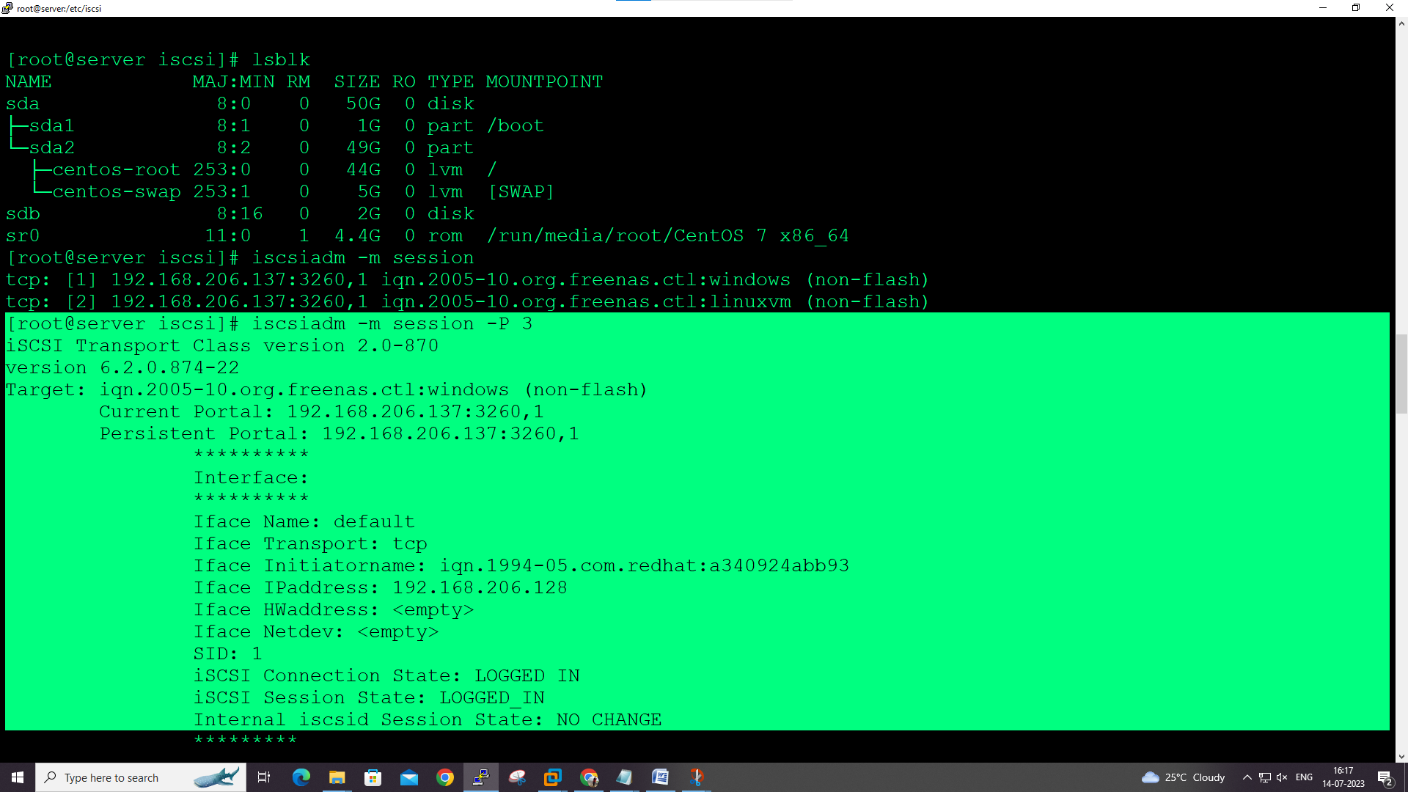

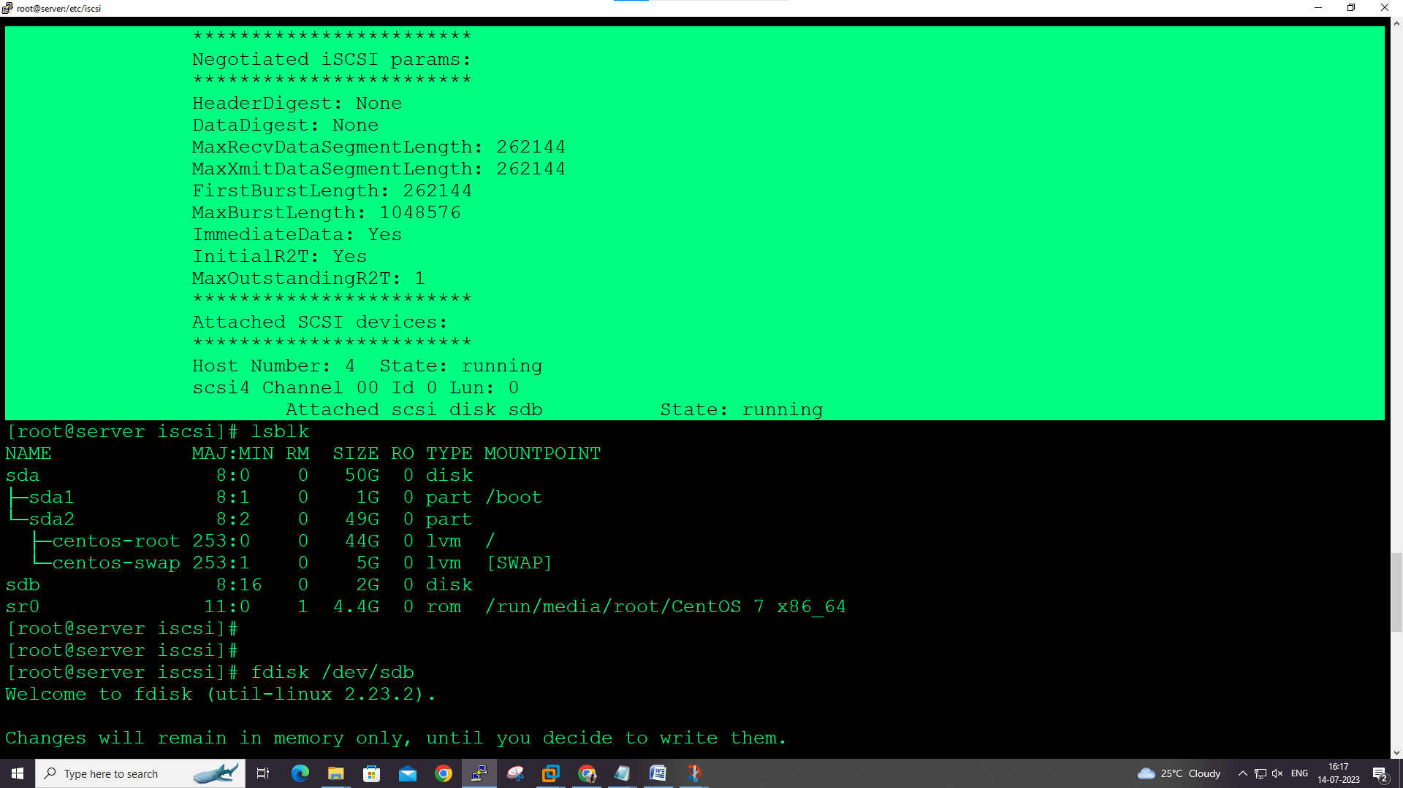

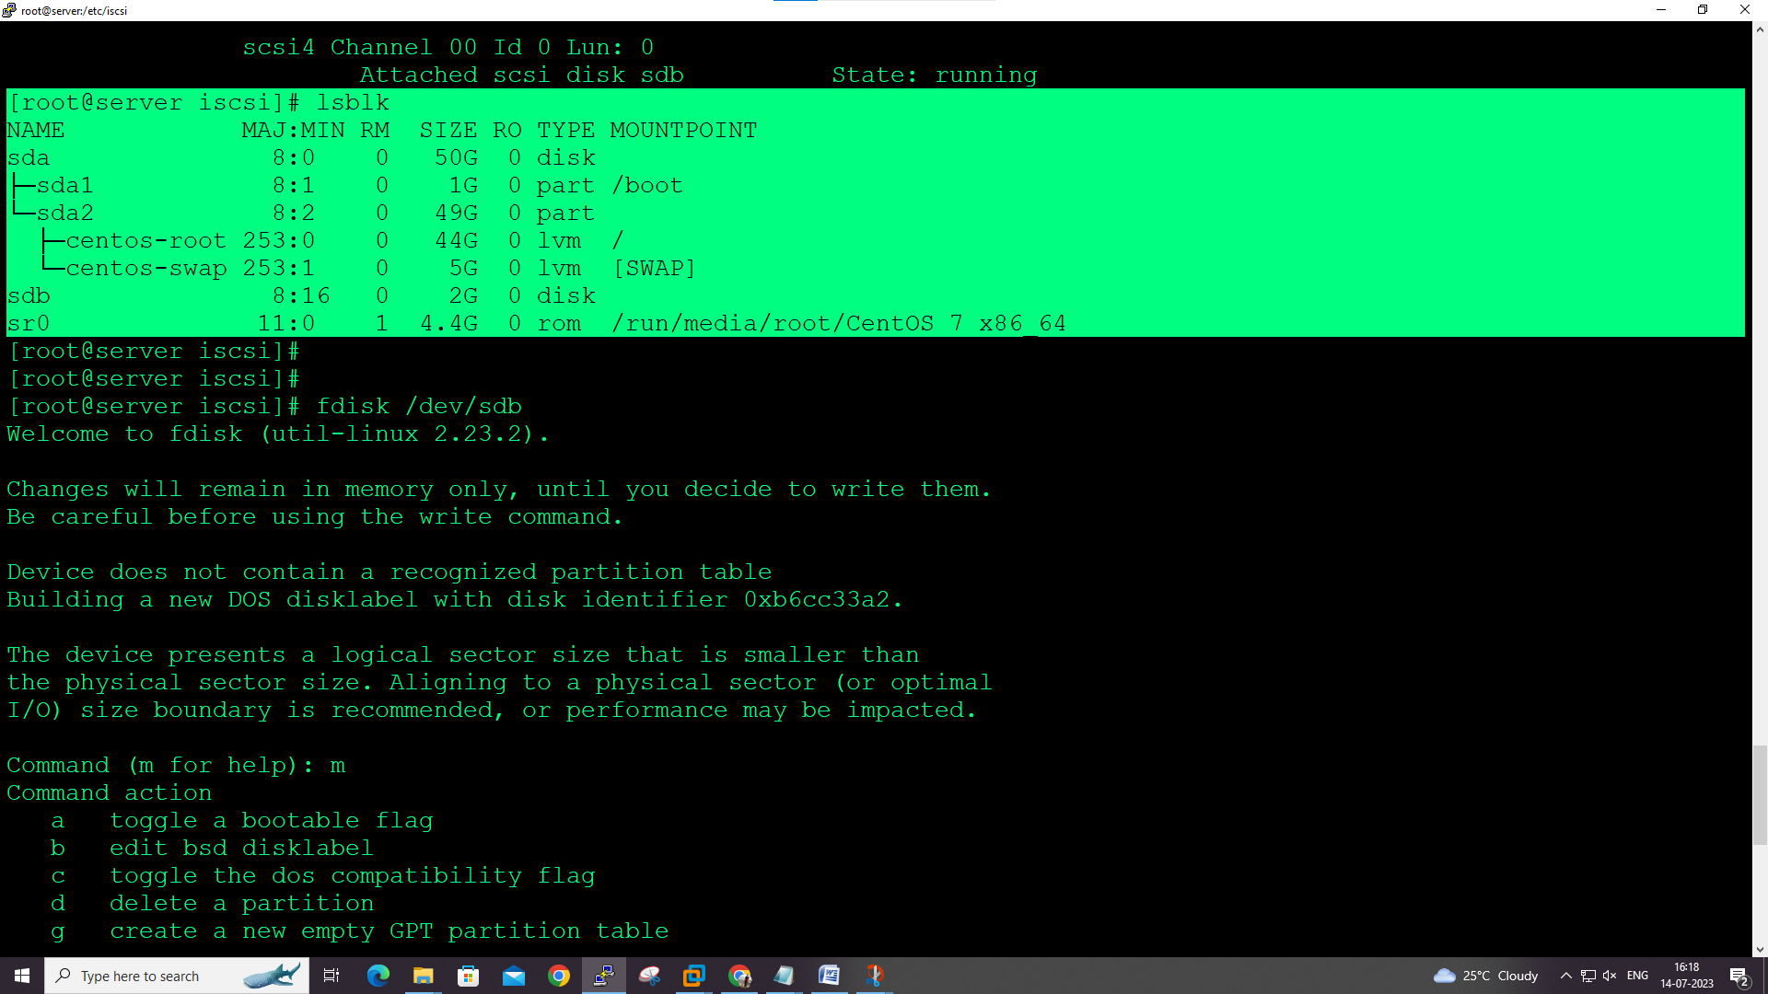

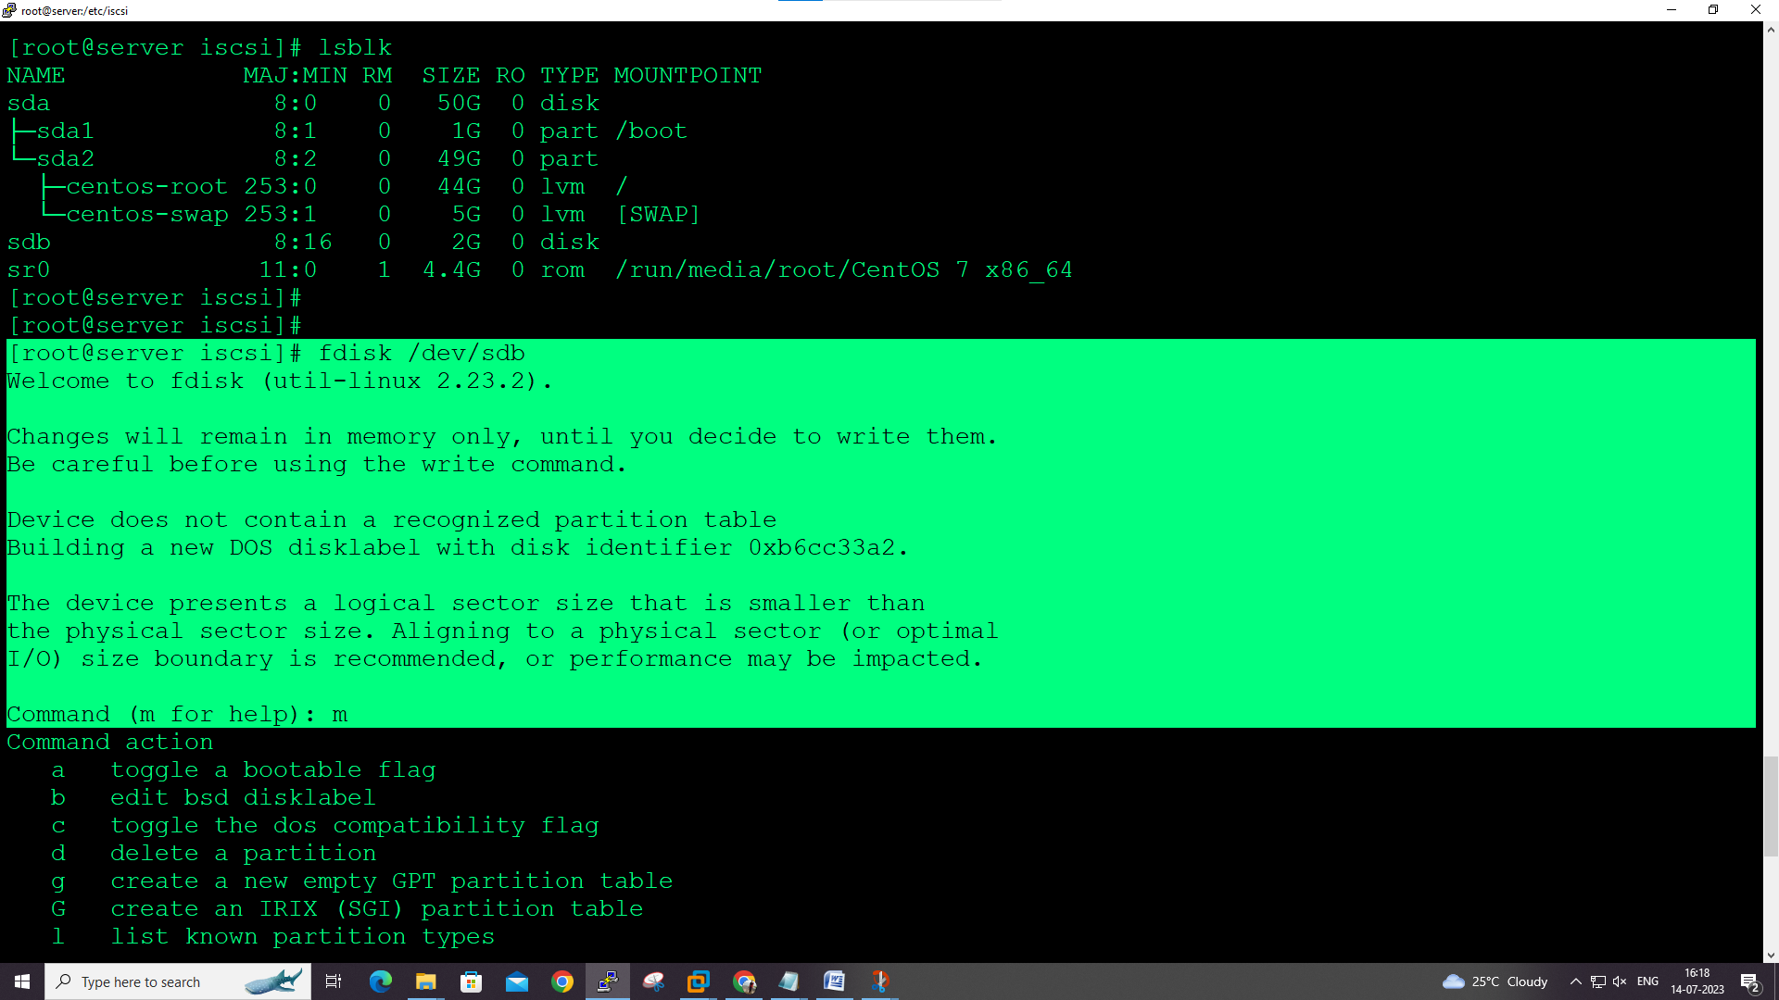

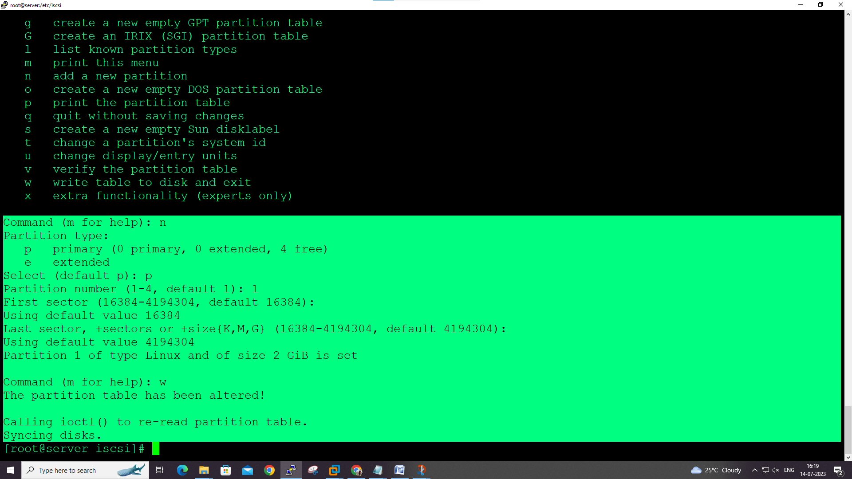

iscsiadm –m node –U all (logout)

**ISCSI mapping on linux client with Manually:**

Add three hard-disk in server machine

Here we provide storage to client manually with following commands.

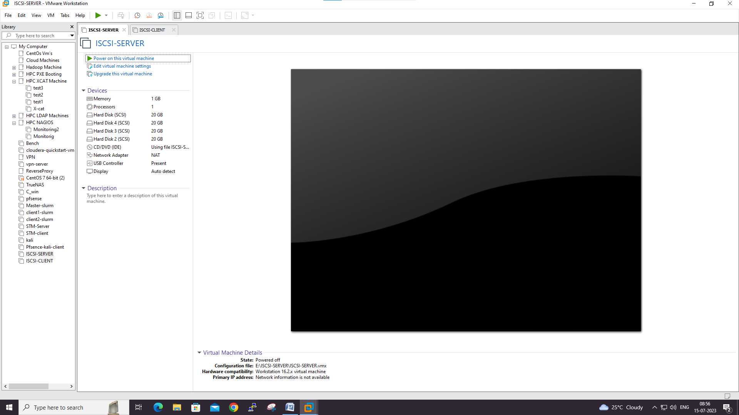

**ON ISCSI CLIENT**

**1. Install the required package for iSCSI:**

**yum install iscsi-initiator-utils**

**This command installs `iscsi-initiator-utils`, which is a daemon for managing Internet Small Computer System Interface (iSCSI) sessions.**

**2. Navigate to the iSCSI directory and check the initiator name:**

**cd /etc/iscsi/**

**cat initiatorname.iscsi # change client name if required**

**This displays the name of the iSCSI initiator, which you can change if necessary.**

**3. Restart the iSCSI service:**

**systemctl restart iscsi**

**This restarts the iSCSI service, applying any changes made to its configuration.**

**--**

**ON ISCSI SERVER**

**1. Check the available disk drives:**

**fdisk -l**

**This command lists all disk partitions.**

**2. Create physical volumes for the new drives:**

**pvcreate /dev/sdc /dev/sdb**

**This command creates physical volumes on the specified devices, which can be used to build a volume group.**

**3. Create a volume group:**

**vgcreate vg_iscsi /dev/sdb /dev/sdc**

**This creates a volume group named `vg_iscsi` using the previously created physical volumes.**

**4. Create logical volumes:**

**lvcreate -n lv_iscsi-disk-01 -l 1G vg_iscsi**

**lvcreate -n lv_iscsi-disk-01 -L 1G vg_iscsi**

**These commands create two logical volumes named `lv_iscsi-disk-01` in the volume group `vg_iscsi`.**

**5. Check the logical volumes:**

**lvs**

**This displays the information about all available logical volumes.**

**6. Install the package `targetcli`:**

**yum install targetcli**

**This installs `targetcli`, a command-line interface for managing Linux kernel storage targets.**

**7. Configure the target and map it to the iSCSI client:**

**targetcli**

**cd backstores/block**

**create block1 /dev/mapper/vg_iscsi-lv_iscsi--disk--01**

**cd iscsi**

**create iqn.2022-12.cdac.acts.hpcsa.sbm:disk1**

**cd iqn.2022-12.cdac.acts.hpcsa.sbm:disk1/tpg1/acls**

**create iqn.2022-12.acts.student:306631cea220 #client PC iscsi initiator name**

**cd iscsi/iqn.2022-12.cdac.acts.hpcsa.sbm:disk1/tpg1/luns**

**create /backstores/block/block1**

**exit**

**These commands create an iSCSI target using `targetcli`, associate a block device with it, and map the iSCSI initiator (client) to the target.**

**8. Restart the `target` service:**

**systemctl restart target**

**This command restarts the `target` service, applying any changes made to its configuration.**

**9. Check the status of the `target` service:**

**systemctl status target**

**This displays the status of the `target` service.**

**---**

**ON ISCSI CLIENT AGAIN**

**1. Login to the iSCSI target:**

**iscsiadm -m -t st -p 192.168.76.XXX --login #XXX=server ip**

**This command logs in to the iSCSI target on the specified IP address.**

**2. Discover the iSCSI target:**

**iscsiadm -m discovery -t st -p 192.168.76.XXX --login #XXX=server IP**

**This command discovers iSCSI targets on the specified IP address.**

**3. Check the available disk drives again:**

**fdisk -l**

**This command lists all disk partitions, including the new iSCSI device.**

**4. Format and mount the new iSCSI disk:**

**fdisk /dev/sdx #use X=iscsi mount disk**

**#Press n then enter enter**

**#Press key w**

**fdisk -l**

**mkdir /mnt/disk-1**

**mkfs.ext4 /dev/sdx1**

**mount /dev/sdh1 /mnt/disk-1/**

**These commands create a new partition on the iSCSI disk, format it with the ext4 filesystem, and mount it at `/mnt/disk-1`.**